Objective cover
To reduce the amount of light contamination from the VR monitors, into the PMTs of the microscope, we have created an objective cover. This design has been designed and used for the objective model (Nikon LWD 16x /0.80W DIC N2 WB 3.0). The cover has been printed using a Form2 3D printer with 100 microns of resolution and the Clear V4 resin type.
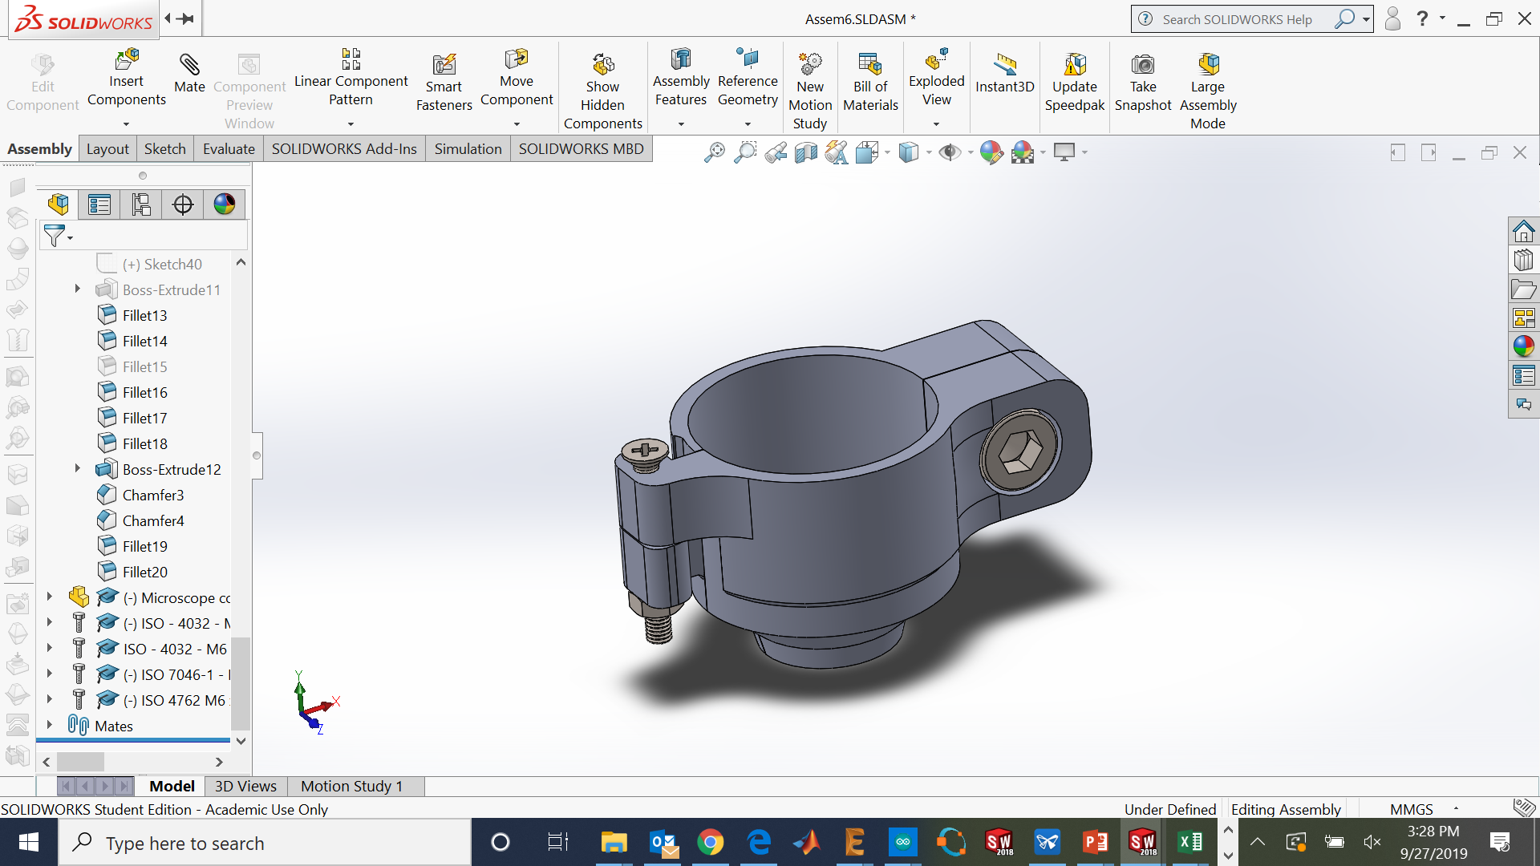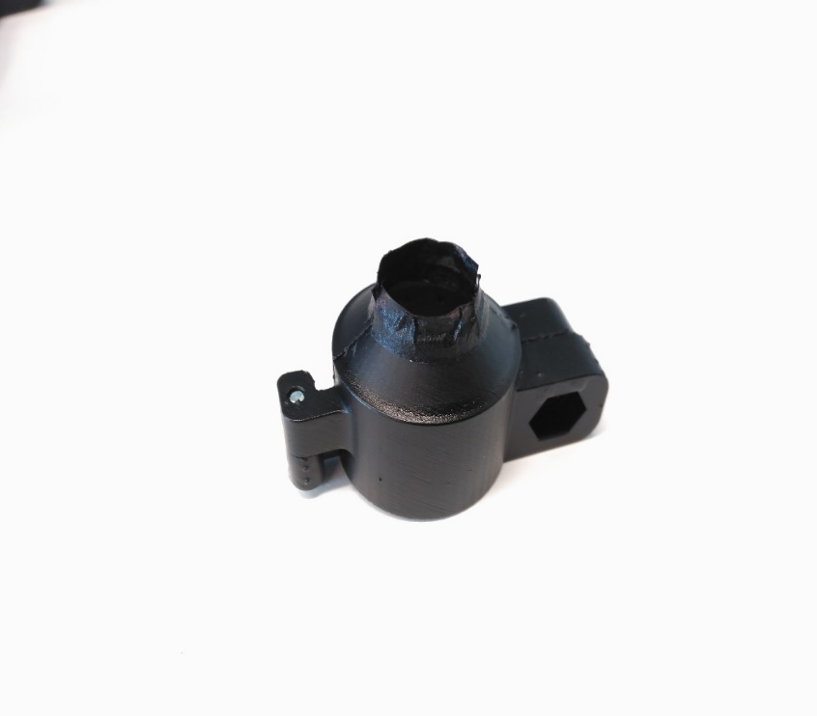
Figure 1: Objective cover on the CAD program (left) and manufactured (right).
Assembly instructions
- Get all the components and print the two 3D printable parts.
Part name | Manufacturer | Units | Reference
Left cover | 3D printed part | 2 | Microscope left cover.STL
Right cover | 3D printed part | 2 | Microscope right cover.STL
M6 Allen screw 16 mm | RS Components | 1 | RS Components 281-114
M6 nut | RS Components | 1 | RS Components 525-919
M3 Screw 25 mm | RS Components | 1 | RS Components 908-7497
M3 nut | RS Components | 1 | RS Components 524-281

- Once the parts have been printed, have been painted with black paint spray and a small piece of black tape (approximately 4 mm) has been added to cover the space between the head coverslip and the edge of the microscope cover.
- Insert the M3 screw into the hinge using the M3 nut as a stopper.
- Insert the M6 nut in the hexagonal space (optional).
- Insert the M6 screw on the hole and the cover can be closed by screwing the M6 screw.
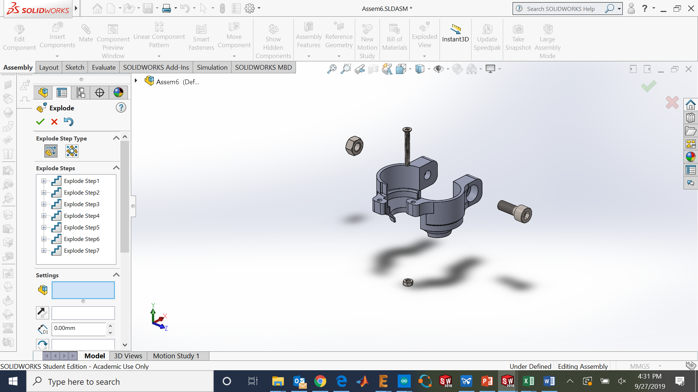
Figure 2: Elements for the assembly.

